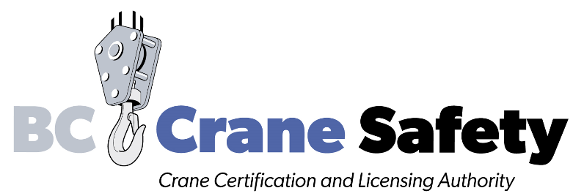

Credential Recognition

Other Jurisdictions

Application Package

Crane operators with credentials from Canadian provinces and territories, the United States, Ireland, the United Kingdom, and some European Union nations can work in British Columbia if their home jurisdiction credential is recognized by BC Crane Safety. Canadian Immigration laws apply.

How to Complete this Package

Crane operators from outside British Columbia can apply for their home jurisdiction credential to be recognized in the following crane trades:

- Tower crane
- Mobile cranes
- Boom trucks (Canadian jurisdictions only)

Credential recognition is confirmed by BC Crane Safety. There is no fee for this service.

If your credential is recognized in BC, you will be notified by BC Crane Safety and be issued a digital card. This is the official credential recognition that enables you to operate a designated crane classification in British Columbia based on your home jurisdiction credential. You are responsible for maintaining your home jurisdiction credential and/or obtaining a BC credential for the same crane classification. Apprentice operators must renew annually for a maximum of three times.

The official credential recognition digital card is designed to be displayed on a phone or tablet. Credential recognition can also be verified online at Credential Check using your BC Crane Safety ID and last name. WorkSafeBC Prevention officers can email BC Crane Safety at info@bccranesafety.ca to request verification.

Everyone who operates a crane in BC must have current knowledge of sections of the Workers Compensation Act, Occupational Health and Safety Regulation (OHSR), OHSR Guidelines, Policies and Standards that apply to cranes in the province. See page 4 for more information.

The OHSR requires BC employers to provide orientation to new hires before allowing workers to perform their job. This is to make sure new workers understand their responsibilities as crane operators.

Do the following:

- Review all the information in this document and the regulatory resource links.

- Complete the application form. Sign and date it. Apprentices must also include the signature of their employer. The employer must be the registered apprenticeship sponsor. Processing will be delayed if information is missing.

- Attach a copy of your credential and any other documents listed on page 3.

- Provide a photo of yourself (the crane operator). This photo will be used for your digital card.
- Include your head and shoulders
- Take the picture in front of a plain, light-coloured background
- Don’t wear a hat or sunglasses
- The photo can be taken with a phone or digital camera

Send the paperwork to BC Crane Safety

Include the following:
- Application – Date and sign the form. Apprentices must have their employer’s signature. The employer must be the registered apprenticeship sponsor.
- Copy of your credential and any other required documents – see page 3. IF SENDING BY MAIL, DO NOT SEND ORIGINAL CREDENTIALS.
All copies must be clear and legible. If we can’t read them, your application will be delayed.
- Photo.

Then:
- Scan and email it to info@bccranesafety.ca
or
- Send it by mail to: BC Crane Safety PO Box 42066 RPO Guildford
Surrey, BC
V3R 1S5

Payment
There is currently no fee for this service.

Out-of-Jurisdiction Certificate Information

MANITOBA APPLICANTS
Apprenticeship Manitoba requires a disclosure form before they will release information about an operator’s credentials.

Complete the Disclosure of Client Credentials form and mail or fax it to Apprenticeship Manitoba. The addresses and fax numbers are at the bottom of the form.

Send a copy of the completed form to BC Crane Safety. We will follow up with them to verify your certificate.

APPLICANTS FROM OTHER CANADIAN PROVINCES/TERRITORIES
Please include a copy of your certificate.

UNITED STATES APPLICANTS
Please include copies of the following:
- CIC, NCCER, NCCCO, or OECP Mobile Crane certificate
- Advanced Rigger certificate
- BC Practical Crane Levelling examination (not required for tower crane)

IRELAND APPLICANTS
Please include copies of the following:
- SOLAS registration card
- CSCS card (or FAS card if issued before 26 October 2013)

UNITED KINGDOM APPLICANTS
Please include copies of the following:
- CPCS certificate
- Individual ID/registration number or National Insurance number

EUROPEAN UNION APPLICANTS
Please include a copy of your ECOL license.

WorkSafeBC Review Material

To operate a boom truck, mobile or tower crane in BC you will need to be able to:
- explain, in general terms, how the OHSR applies to crane operations in BC
- list the general duties of employers, workers, and supervisors as described in the OHSR
- describe the competencies required for being a crane operator in BC.

Most of the regulatory information that applies to BC crane operators is posted on the WorkSafeBC website under the Law and Policy Section. WorkSafeBC is the Workers’ Compensation Board in BC.
Here is the key information you will need to be familiar with.

Workers Compensation Act

You can see the full Workers Compensation Act here. It describes the occupational health and safety responsibilities of workers, employers and others in BC and explains how the compensation system works. Here is one essential section:
- Part2: Division 4 - General Duties of Employers, Workers and Others

Occupational Health and Safety Regulation (OHSR)

BC’s Occupational Health and Safety Regulation (OHSR) is enforced by WorkSafeBC. You can view the entire OHSR here in a searchable version that also includes the OHSR Guidelines which give more detail about how each part is interpreted. Here are some of the main parts you will need to be familiar with:
- Part 3 - Rights and Responsibilities
- Part 13 - Ladders, Scaffolds and Temporary Work Platforms
- Part 14 - Cranes and Hoists
- Part 15 - Rigging
- Part 16 - Mobile Equipment
- Part 19 - Electrical Safety

Operator Information please print clearly

Legal First Name Legal Middle Name Legal Last Name

Address Apt / Suite

City Province Postal Code

( ) - | ( ) - | ( ) -
Phone | Cell | Fax

dd /mm /yyyy
Email Date of Birth

BC Crane Safety ID Number (Mandatory)

I certify that the information provided is complete and accurate and that I have read and understand the required sections of the Workers Compensation Act and the Occupational Health and Safety Regulation, Policies, Guidelines and Standards. I authorize BC Crane Safety to use and disclose the personal information I have provided on this form and the copy of my certificate/credential for the purpose of verification of my out-of-jurisdiction trade qualification.

dd /mm /yyyy
Applicant Signature

Employer Information please print clearly
Mandatory for apprentices

Company Name WorkSafeBC Account Number

Address Suite

City Province Postal Code

Contact Name Email

( ) - ( ) - ( ) -
Phone Cell Fax

Agreement
BC Crane Safety Credential Recognition – Other Jurisdictions – Apprentice
PLAN FOR SUPERVISION

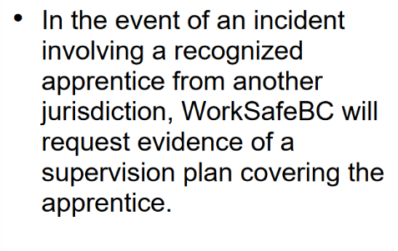  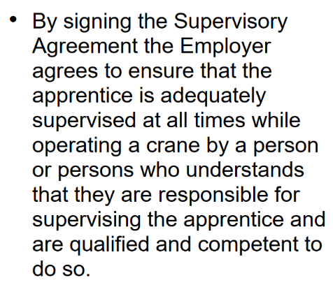  - While you do not have to  submit one with this  application, you will need to ensure that a supervision plan is in place to ensure adequate supervision of the apprentice named on this form. | - In the event of an incident involving a recognized  apprentice from another jurisdiction, WorkSafeBC will request evidence of a supervision plan covering the apprentice. | - By signing the Supervisory Agreement the Employer  agrees to ensure that the apprentice is adequately supervised at all times while operating a crane by a person or persons who understands that they are responsible for supervising the apprentice and are qualified and competent to  do so.

Apprentice / Trainee Crane Operator: Please note that the BC credential recognition of your apprentice credential from another jurisdiction is not transferable to other employers. Your employer must be your registered apprenticeship sponsor.
If you change jobs, your BC credential recognition becomes non-compliant and you must notify BC Crane Safety of your change of employer.

Apprentice / Trainee Crane Operator | Employer
I have read and understood all the conditions in this application and I agree to operate only crane(s) within the classification indicated on the credential attached to this application under the supervision of a qualified supervisor. | I have read and understood all the conditions in this application and I agree that the trainee crane operator will be adequately supervised while operating crane(s) within the classification as indicated on the credential attached to this application.  I am the registered apprenticeship sponsor for this apprentice.
Apprentice / Trainee: Legal First & Last Name  Please print clearly | Employer: Legal First & Last Name  Please print clearly
Apprentice / Trainee: Signature | Employer: Signature
dd /mm /yyyy | dd /mm /yyyy

